Date: August 3, 2021
To: Weber County Board of County Commissioners

From: Ronna Tidwell
Community Development Department

Agenda Date: August 10, 2021

Subject: Request to Declare Parcel Number 13-093-0022 as Surplus Property

Attachments: A - Aerial View of Parcel
B - Recorder’s Plat
C – Market Value

_____________________________________________________________________________________

Summary:
A Weber County owned parcel of land, identified as Tax ID #13-093-0022, was acquired by the County through a tax sale process and deed executed in 1956. The parcel contains approximately .01 acres.
The County has been contacted by an adjacent property owner and was asked if the County would consider selling this property.
Weber County has no intended use for this property; therefore, it can be declared surplus and offered to an interested buyer. In order to convey real property, the County Commission must first take action to declare this parcel as surplus property.

Property Description:
13-093-0022

THE NORTH 8 FEET OF VACATED ALLEY ADJOINING LOT 19, BLOCK 19, NOB HILL ADDITION, OGDEN CITY, WEBER COUNTY, UTAH, ON THE SOUTH.

Recommendation:
Declare Parcel 13-093-0022 as surplus property.

Attachment A
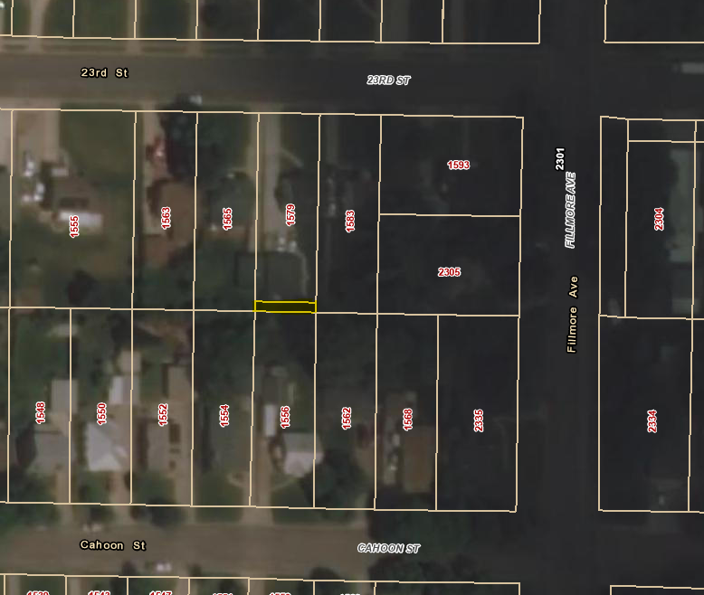

Attachment B
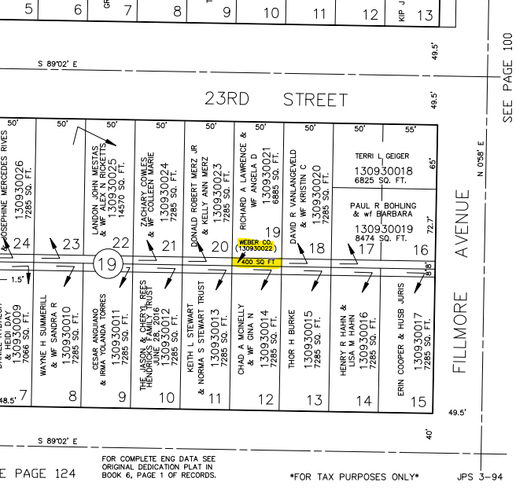

Attachment C
